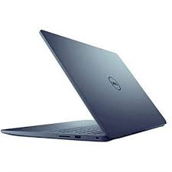

Dell Inspiron 15

* 11th Generation Core I5
* 8MB Cache
* 4GB DDR4, 1TB 5400
* 2GB Graphics Memory
* **Rs.127,900**